**Chapter four**

**RESULTS**

**Diabetes distribution profile on gender:**

Table 1: Diabetes distribution profile on gender:

|  |  |  |  |  |  |
| --- | --- | --- | --- | --- | --- |
| **Gender** | | | | | |
|  | | **Frequency** | **Percent** | **Valid Percent** | **Cumulative Percent** |
| **Valid** | **Female** | **114** | **57.0** | **57.0** | **57.0** |
| **Male** | **86** | **43.0** | **43.0** | **100.0** |
| **Total** | **200** | **100.0** | **100.0** |  |

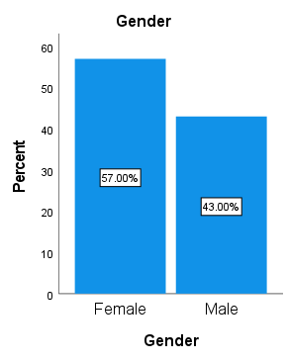

Figure 1: Diabetes distribution profile on gender

Comment: Among 200 people, 57% were female and 43% were male patients suffering from DM.

**Diabetic patients’ distribution profile on age:**

Table 2:Diabetic patients’ distribution profile on age:

|  |  |  |  |  |  |
| --- | --- | --- | --- | --- | --- |
| **Age Group** | | | | | |
|  | | **Frequency** | **Percent** | **Valid Percent** | **Cumulative Percent** |
| Valid | 20-30 | **45** | **22.5** | **22.5** | **22.5** |
| 30-40 | **43** | **21.5** | **21.5** | **44.0** |
| 40-50 | **36** | **18.0** | **18.0** | **62.0** |
| 50-60 | **43** | **21.5** | **21.5** | **83.5** |
| 60+ | **33** | **16.5** | **16.5** | **100.0** |
| Total | **200** | **100.0** | **100.0** |  |

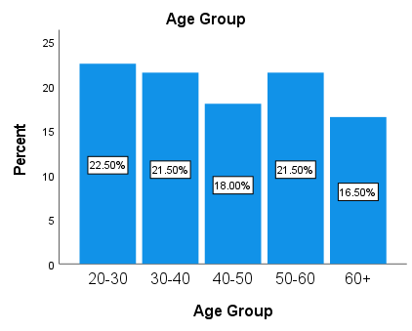

Figure 2: Diabetic patients’ distribution profile on age

Comment: Among 200 people, 22.5% were in age group 20-30, 21.5% were in age group 30-40, 18% were in age group 40-50, 21.5% were in age group 50-60, and remaining were above age 60.

**Diabetic patients’ distribution profile on family history:**

Table 3:Diabetic patients’ distribution profile on family history:

|  |  |  |  |  |  |
| --- | --- | --- | --- | --- | --- |
| **Family History About Diabetes** | | | | | |
|  | | **Frequency** | **Percent** | **Valid Percent** | **Cumulative Percent** |
| **Valid** | **Do not Know** | **77** | **38.5** | **38.5** | **38.5** |
| **No** | **69** | **34.5** | **34.5** | **73.0** |
| **Yes** | **54** | **27.0** | **27.0** | **100.0** |
| **Total** | **200** | **100.0** | **100.0** |  |

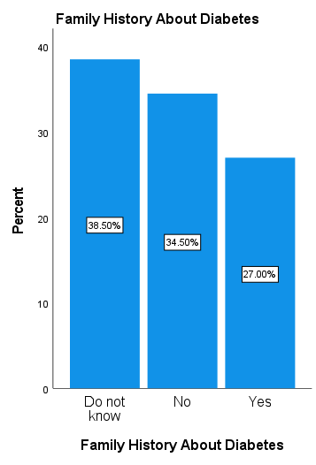

Figure 3: Diabetic patients based on Family History

Comment: Among 200 people 38.5% were do not about diabetic, 34.5% people were non diabetic and 27% were diabetic.

**Distribution of diabetic patients based on types of diabetes:**

Table 4: Distribution of diabetic patients based on types of diabetes:

|  |  |  |  |  |  |
| --- | --- | --- | --- | --- | --- |
| **Type of Diabetes Mellitus** | | | | | |
|  | | **Frequency** | **Percent** | **Valid Percent** | **Cumulative Percent** |
| **Valid** | **Do not know** | **59** | **29.5** | **29.5** | **29.5** |
| **Type-1** | **77** | **38.5** | **38.5** | **68.0** |
| **Type-2** | **64** | **32.0** | **32.0** | **100.0** |
| **Total** | **200** | **100.0** | **100.0** |  |

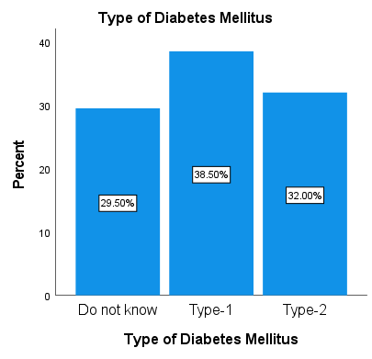

**Figure 4: Distribution based on types of diabetes**

Comment: Among 200 people, 29.5% were do not know about types of diabetes, 38.5% were type-1 diabetes and 32% were type-2 diabetes.

**Distribution based on exercise status:**

Table 5: Distribution based on exercise status:

|  |  |  |  |  |  |
| --- | --- | --- | --- | --- | --- |
| **Undertake Physical Exercise** | | | | | |
|  | | **Frequency** | **Percent** | **Valid Percent** | **Cumulative Percent** |
| **Valid** | **Never** | **66** | **33.0** | **33.0** | **33.0** |
| **Regularly** | **67** | **33.5** | **33.5** | **66.5** |
| **Sometimes** | **67** | **33.5** | **33.5** | **100.0** |
| **Total** | **200** | **100.0** | **100.0** |  |

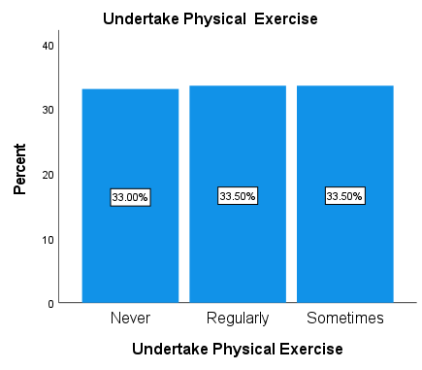

**Figure 5: Distribution based on Physical Exercise**

Comment: Among 200 people, 33% were the patients who didn’t take exercise, 33.5% were the patient who took exercise sometimes and 33.5% were the patients who took exercise regularly.

**Distribution based on Types of Physical exercise:**

Table 6: Distribution based on Types of Physical exercise:

|  |  |  |  |  |  |
| --- | --- | --- | --- | --- | --- |
| **Type of Physical Exercise** | | | | | |
|  | | **Frequency** | **Percent** | **Valid Percent** | **Cumulative Percent** |
| **Valid** | **Do not Take** | **47** | **23.5** | **23.5** | **23.5** |
| **Running** | **46** | **23.0** | **23.0** | **46.5** |
| **Walking** | **62** | **31.0** | **31.0** | **77.5** |
| **Weight Training** | **45** | **22.5** | **22.5** | **100.0** |
| **Total** | **200** | **100.0** | **100.0** |  |

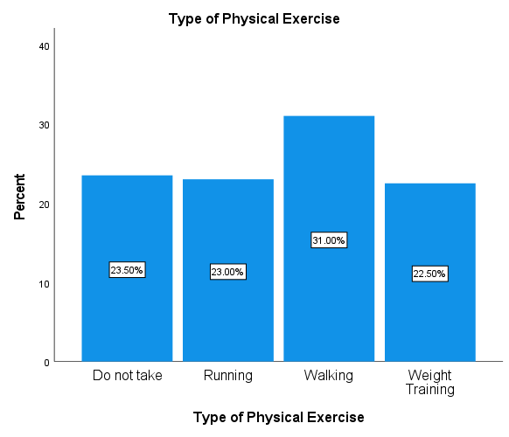

**Figure 6: Distribution based on Types of Physical Exercise**

Comment: Among 200 people, 23.5% were the patients who didn’t take exercise, 23% were the patient who took running exercise, 31% were the patients who took walking exercise and 22.5% who took Weight Training exercise.

**Distribution based on dosage of drugs:**

Table 7: Distribution based on dosage of drugs:

|  |  |  |  |  |  |
| --- | --- | --- | --- | --- | --- |
| **Types of Dosages Form of Drugs** | | | | | |
|  | | **Frequency** | **Percent** | **Valid Percent** | **Cumulative Percent** |
| **Valid** | **Capsules** | **62** | **31.0** | **31.0** | **31.0** |
| **Insulin** | **74** | **37.0** | **37.0** | **68.0** |
| **Tablets** | **64** | **32.0** | **32.0** | **100.0** |
| **Total** | **200** | **100.0** | **100.0** |  |

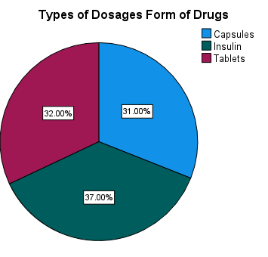

**Figure 7: Distribution based on Types of Dosages Form of Drugs**

Comment: Among 200 people, 31% were the patients who use Capsules, 37% were the patient who use Insulin and 32% were the patients who use Tablets.

**Distribution based on Insulin is Taken:**

Table 8: Distribution based on Insulin is Taken

|  |  |  |  |  |  |
| --- | --- | --- | --- | --- | --- |
| **Insulin is Taken Including** | | | | | |
|  | | **Frequency** | **Percent** | **Valid Percent** | **Cumulative Percent** |
| **Valid** | **Actrapid** | **48** | **24.0** | **24.0** | **24.0** |
| **Diasulin 30/70** | **42** | **21.0** | **21.0** | **45.0** |
| **Insulated** | **37** | **18.5** | **18.5** | **63.5** |
| **Novomix 70/80** | **73** | **36.5** | **36.5** | **100.0** |
| **Total** | **200** | **100.0** | **100.0** |  |

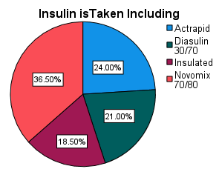

Figure 8: Distribution based on Insulin is Taken

Comment: Among 200 people, 24% were the patients who use Actrapid, 21% were the patient who use Diasulin 30/70, 18.5% were the patients who use Insulated and 36.5% were the patients who use Novomix 70/80.

**Distribution based on Prescribed Tablets Including For CvD**

Table 9: Distribution based Prescribed Tablets Including For CvD

|  |  |  |  |  |  |
| --- | --- | --- | --- | --- | --- |
| **Prescribed Tablets Including For CvD** | | | | | |
|  | | **Frequency** | **Percent** | **Valid Percent** | **Cumulative Percent** |
| **Valid** | **Aspirin** | **45** | **22.5** | **22.5** | **22.5** |
| **Glyceryl** | **56** | **28.0** | **28.0** | **50.5** |
| **Others** | **43** | **21.5** | **21.5** | **72.0** |
| **Ramipil** | **56** | **28.0** | **28.0** | **100.0** |
| **Total** | **200** | **100.0** | **100.0** |  |

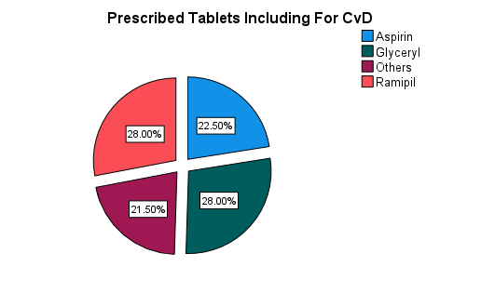

**Figure 8: Distribution based on Types of Dosages Form of Drugs**

Comment: Among 200 people, 22.5% used Aspirin, 28% used by Glyceryl, 28% used by Ramipil and 21.5% used by others.

**Distribution based on Blood Sugar Level**

Table 9: Distribution based on Blood Sugar Level

|  |  |  |  |  |  |
| --- | --- | --- | --- | --- | --- |
| **Blood Sugar Level Average Per Week** | | | | | |
|  | | **Frequency** | **Percent** | **Valid Percent** | **Cumulative Percent** |
| **Valid** | **10.00-15.00** | **59** | **29.5** | **29.5** | **29.5** |
| **15.00- Above** | **51** | **25.5** | **25.5** | **55.0** |
| **6.00-7.00** | **36** | **18.0** | **18.0** | **73.0** |
| **7.00-10.00** | **54** | **27.0** | **27.0** | **100.0** |
| **Total** | **200** | **100.0** | **100.0** |  |

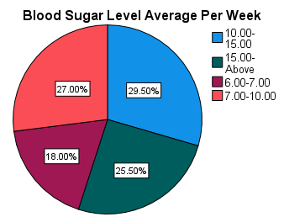

**Figure 9: Distribution based on Blood Sugar Level**

Comment: Among 200 people, 29.5% Average Per Week is 10-15, 25.5% Average Per Week is 15-Above, 18% Average Per Week is 6-7 and 27% Average Per Week is 7-10.

**Distribution based on Heart Disease**

Table 9: Distribution based on Heart Disease

|  |  |  |  |  |  |
| --- | --- | --- | --- | --- | --- |
| **Heart Disease Occurred** | | | | | |
|  | | **Frequency** | **Percent** | **Valid Percent** | **Cumulative Percent** |
| **Valid** | **No** | **111** | **55.5** | **55.5** | **55.5** |
| **Yes** | **89** | **44.5** | **44.5** | **100.0** |
| **Total** | **200** | **100.0** | **100.0** |  |

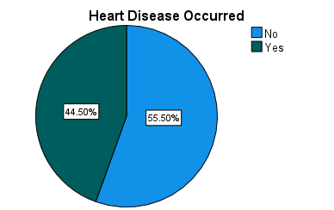

**Figure 9: Distribution based on Heart Disease**

Comment: Among 200 people, 55.5% were the patients who didn’t have Heart Disease and 44.5% were the patients who did have Heart Disease.